
American International University-Bangladesh (AIUB)
Department of Computer Science
Faculty of Science &Technology (FST)
FALL 25 26
Section: A
Software Quality Assurance and Testing
Smart Health Advisory and Awareness System
A Report submitted
By

SN | Student Name | Student ID
1 | ZOBAYER ISLAM JONY | 22-48179-2
2 | SHEMANTO | 22-48653-3
3 | AFIA SULTANA | 22-47097-1
4

Checked By Industry Personnel (Optional)

Name:

Designation:

Company:

Sign:

Date:

Software Test Plan

for
Smart Health Advisory and Awareness System (SHAAS)
Version 1.0 approved
Prepared by Zobayer Islam Jony, Shemanto, Afia Sultana
American International University-Bangladesh (AIUB)
Date Created: 01-01-2026

Table of Contents
Revision History 3
1. TEST PLAN IDENTIFIER: RS-MTP01.3 3
2. REFERENCES 3
3. INTRODUCTION 3
Background to the Problem 3
Solution to the Problem 4
4. REQUEIREMNT SPECIFICATION 4
4.1 System Features 4
4.2 System Quality Attributes 4
4.3 System Interface 5
4.4 Project Requirements 5
5. FEATURES NOT TO BE TESTED 5
6. TESTING APPROACH 5
6.1 Testing Levels 5
6.2 Test Tools 6
6.3 Meetings 6
7. TEST CASES/TEST ITEMS 6
8. ITEM PASS/FAIL CRITERIA 7
9. TEST DELIVERABLES 7
10. STAFFING AND TRAINING NEEDS 8
11. RESPONSIBILITIES 8
12. TESTING SCHEDULE 8
13. PLANNING RISKS AND CONTINGENCIES 9
14. APROVALS 9

Revision History
Revision | Date | Updated by | Update Comments
0.1 | 2026-01-01 | Zobayer Islam Jony | Initial draft (scope + outline).
0.2 | 2026-01-03 | Shemanto | Updated requirements, approach, and tools.
0.3 | 2026-01-05 | Afia Sultana | Added detailed test cases and criteria.
0.4 | 2026-01-08 | Zobayer Islam Jony | Added schedule and risk plan.
1.0 | 2026-01-15 | Team | Final review and formatting.

1. TEST PLAN IDENTIFIER: Smart Health Advisory and Awareness System (SHAAS) — RS-MTP01.3

REFERENCES
Any reference documents associated with this test plan:
• Software Requirement Specification (SRS) — Smart Health Advisory and Awareness System (SHAAS), Version 1.0
• UI Prototype/Wireframes (Figma export or screen mock‑ups)
• Database Schema and API Contract Documents (Authentication, Profile, Tracking, Appointment, Chat, Notifications)
• Security & Privacy Guidelines (OTP policy, encryption, consent, data retention)
• Third‑party documentation: Maps/GPS SDK, Weather/AQI API, Notification service, Payment gateway

INTRODUCTION

Background to the Problem
Smart Health Advisory and Awareness System (SHAAS) targets a common challenge in everyday life: people want quick, clear, and trustworthy health guidance, but the information they find is often scattered, confusing, or not personalized. At the same time, many users do not track basic indicators such as weight, activity, sleep, or hydration—so they miss early signals and preventive actions. This results in delayed care, avoidable health complications, and increased financial burden.
Root Cause & Importance:
The primary causes are (1) fragmented sources of health information, (2) limited availability of professional advice for routine questions, and (3) low awareness of preventive habits. Addressing these gaps is critical because early awareness and timely reminders reduce risk, improve quality of life, and lessen pressure on healthcare services.

Solution to the Problem
Proposed Solution:
SHAAS is a user‑centric platform (mobile/web) that combines a personal health profile, calculators (e.g., BMI), reminders/notifications, environmental awareness (weather/AQI), and guided assistance via an AI advisor. The solution is appropriate because it converts health information into practical steps (tips, alerts, and simple tracking) while keeping medical decisions with licensed professionals. It is feasible using standard secure authentication, scalable APIs, and established third‑party services.
Objectives and Benefits:
• Encourage preventive health behavior through daily tips and timely alerts.
• Enable users to monitor common metrics with manual logging and optional passive tracking.
• Provide quick access to support: doctor appointment booking, live chat, and helpline contacts.
• Maintain strong privacy and security controls to protect user data.
Existing Solutions:
Existing options include fitness trackers, standalone BMI calculator apps, and health information sites. However, many solutions are single‑purpose and do not provide a unified workflow that connects personal profile data, reminders, environment context, and support channels. SHAAS consolidates these capabilities in one system to improve convenience and overall awareness.

REQUEIREMNT SPECIFICATION

System Features
Functional Requirements (System Features):
• FR‑01: Free Trial (3 days)
Priority Level: High | Precondition: None
Details: Users can activate a free 3‑day trial to explore premium features. The system must store the start/end time and show an upgrade prompt after expiry.
• FR‑02: Sign Up (Email/Phone + OTP)
Priority Level: High | Precondition: None
Details: Users can create an account using email or phone number. The system validates required fields and verifies identity using OTP.
• FR‑03: Log In
Priority Level: High | Precondition: User account exists
Details: Users can sign in with valid credentials. After repeated failed attempts, the system applies rate limiting and may temporarily lock the account.
• FR‑04: Forgot Password (OTP Reset)
Priority Level: High | Precondition: Registered email/phone
Details: Users can reset password securely using OTP verification and password strength checks.
• FR‑05: User Profile
Priority Level: High | Precondition: User logged in
Details: Users can view and update profile information (age, blood group, height/weight, conditions) and preferences (language, notifications).
• FR‑06: AI Health Advisor (Text)
Priority Level: Medium | Precondition: User logged in
Details: An assistant provides general health guidance, answers common questions, and suggests relevant app features with safety disclaimers.
• FR‑07: Voice Command Navigation
Priority Level: Medium | Precondition: User logged in + microphone permission
Details: Users can navigate key features using voice commands (open BMI, show reminders, open news).
• FR‑08: Notification Alerts
Priority Level: High | Precondition: User logged in
Details: System sends alerts for reminders (medicine, water, appointments) and health‑related updates based on user settings.
• FR‑09: Active & Passive Health Tracking
Priority Level: High | Precondition: User logged in
Details: Users can log metrics manually (weight, steps, sleep) and optionally connect sensor/APIs for passive tracking.
• FR‑10: BMI Calculator
Priority Level: Medium | Precondition: User logged in
Details: System calculates BMI, shows category, stores results, and displays simple trends.
• FR‑11: Weather & Air Quality Updates
Priority Level: Medium | Precondition: Location permission enabled
Details: System displays local weather/AQI and pushes precautionary alerts during risky conditions.
• FR‑12: News Portal
Priority Level: Medium | Precondition: User logged in
Details: System shows curated health and environment news, allowing users to open and read details.
• FR‑13: Appointment Reservation
Priority Level: High | Precondition: User logged in
Details: Users can book appointments by selecting specialty, doctor, date/time, and receive confirmation with reminders.
• FR‑14: Live Chat Channels
Priority Level: High | Precondition: User logged in
Details: Users can chat with support/health professionals (if available). Chat history is stored securely.
• FR‑15: Helpline
Priority Level: High | Precondition: None
Details: A helpline section provides quick contact options (call/email/chat) and basic emergency guidance.
• FR‑16: Language Selection
Priority Level: Medium | Precondition: None
Details: Users can select preferred language and the preference persists across sessions.
• FR‑17: Log Out
Priority Level: High | Precondition: User logged in
Details: Users can log out securely; the session token is invalidated and user is redirected to Sign In.

System Quality Attributes
Non‑Functional Requirements (Quality Attributes):
• Security: Protect user data via HTTPS, strong password hashing, OTP verification for sensitive actions, and role‑based access where needed.
• Data Privacy: Collect only necessary data with user consent; provide settings to control sharing and tracking; apply data minimization and retention rules.
• Reliability: The app should handle failures gracefully (offline messages, retry mechanisms) and avoid crashes in core flows.
• Performance: Dashboard and common actions should load quickly; API calls should have timeouts and caching for better responsiveness.
• Usability: Clear navigation, simple forms, meaningful error messages, and consistent UI patterns across screens.
• Compatibility: Support common Android versions and modern browsers; responsive layout for multiple screen sizes.
• Accessibility: Readable text, screen‑reader friendly labels, and keyboard navigation for web components.
• Scalability: Support increasing users and future feature expansion (wearables, more chat channels) without redesign.
• Maintainability: Modular codebase, version control, code reviews, and automated tests to reduce regression.

System Interface
The wireframes below represent key interfaces used for functional testing of SHAAS. They help validate required fields, navigation flow, and user-visible outputs during execution.

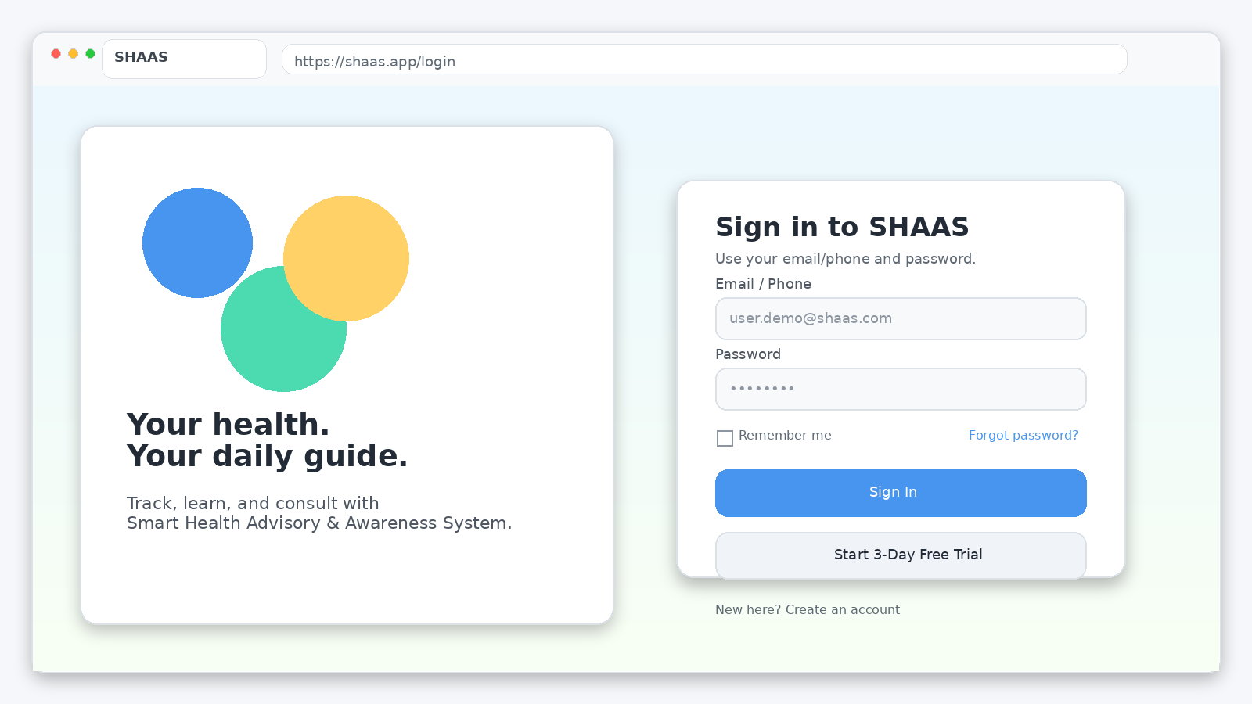
Figure 1: Login Screen (Web Browser UI)
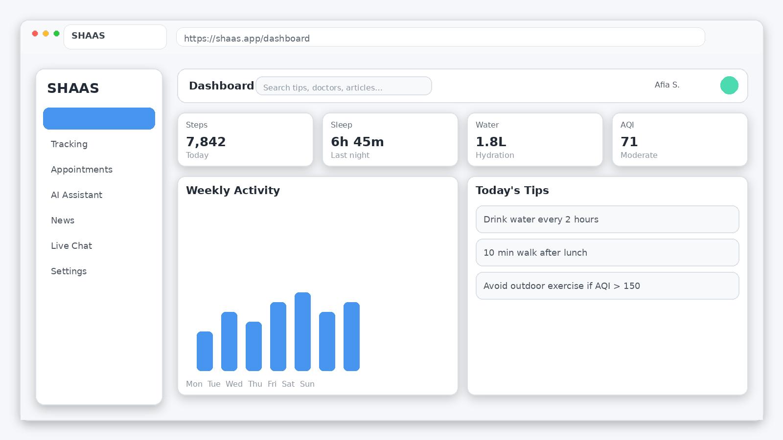
Figure 2: Dashboard Screen (Web Browser UI)

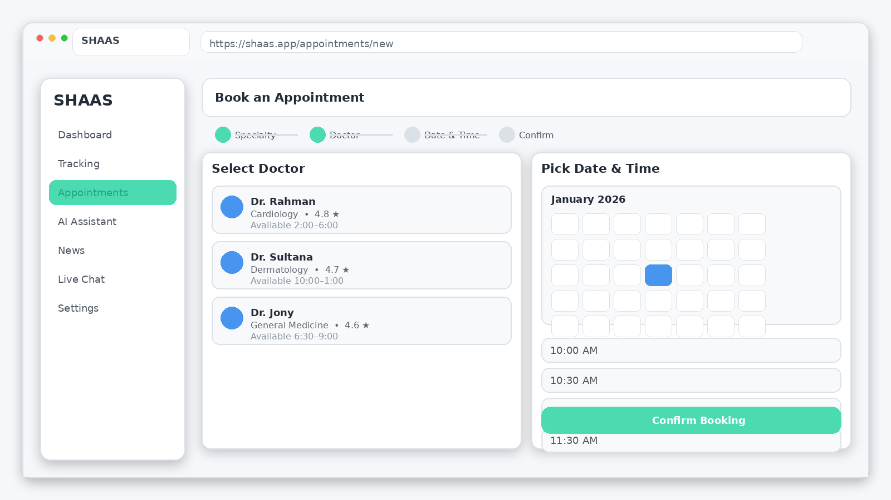
Figure 3: Appointment Booking Screen (Web Browser UI)
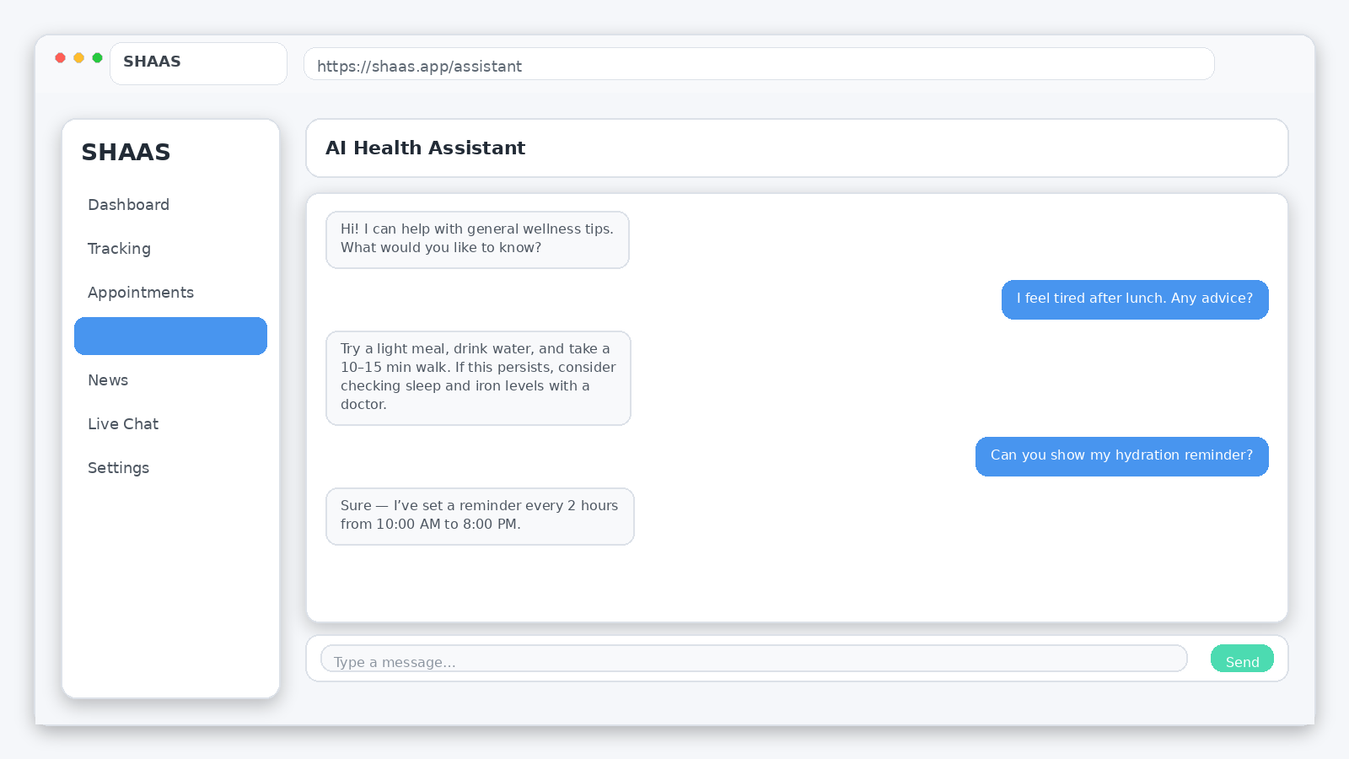
Figure 4: AI Assistant Screen (Web Browser UI)

Project Requirements
Project Constraints and Assumptions:
• Testing Window (required): 01 Jan 2026 – 15 Jan 2026
• Estimated Project Budget (development + QA + deployment): 3,90,000 BDT
– Development & UI/UX: 2,10,000 BDT
– QA & Testing: 80,000 BDT
– Cloud/Hosting & API services: 50,000 BDT
– Contingency/Misc.: 50,000 BDT
• Development Time Assumption: 16 weeks (8 sprints × 2 weeks) + 2 weeks buffer.
• Team Resources (assumed): 1 Product Owner, 1 Scrum Master, 3 Developers, 1 QA Engineer.
• Tools/Environment: VS Code, Android Studio, MySQL/PostgreSQL, Git, Figma, staging server.
• Constraints: limited testing devices, API rate limits, strict privacy expectations for health data.

FEATURES NOT TO BE TESTED
The following areas will not be tested directly (they may be indirectly covered when validating related features):
• Internal behavior of third‑party services (maps/weather/AQI/payment/notification providers). Only our integration, request/response handling, and fallback behavior will be tested.
• Hardware/sensor precision differences across devices (GPS accuracy, step counter precision). We test that the app correctly reads and displays OS-provided values.
• User‑modified external tools (exported reports opened in third‑party apps or spreadsheets).
• Carrier/network outages beyond our control; we test graceful handling only.
• Clinical diagnosis or treatment correctness beyond general educational guidance (doctor decisions are out of scope).

TESTING APPROACH

Testing Levels
Testing for SHAAS will be executed in four levels: Unit, Integration, System, and Acceptance. The plan follows risk‑based testing: security and core user journeys (authentication, reminders, appointments, helpline) are validated first, followed by supporting features (news, language, voice).

UNIT Testing:
Performed by developers for each module/function (e.g., BMI formula, OTP validation, input sanitization, API payload mapping). Evidence includes unit test lists, sample outputs, and defect notes. Unit testing must complete before a module is promoted to the staging environment.
INTEGRATION & SYSTEM Testing:
Led by QA with support from developers. Integration tests verify data flow between modules (signup→OTP→profile→dashboard, booking→notification reminders). System tests validate end‑to‑end workflows, UI consistency, database persistence, and error handling. Entry criteria: build deployed to staging and no open blocking issues from unit testing.
ACCEPTANCE Testing (UAT):
Executed by stakeholders/end users with QA assistance. UAT confirms the system meets business goals and is usable in realistic scenarios. Sign‑off requires successful completion of critical workflows and acceptance criteria, with no open critical defects.

Test Tools
Tools and Utilities:
• Appium — Mobile UI automation (Android).
• Selenium WebDriver — Web UI automation (if a web portal exists).
• Postman/Newman — API test execution and regression collections.
• JMeter — Load/performance testing for backend services/APIs.
• OWASP ZAP — Baseline security scanning for common vulnerabilities.
• Android Studio Emulator + Physical Devices — Device and permission behavior testing.
• Git + Issue Tracker (GitHub Issues/Jira/Trello) — versioning and defect tracking.
• Figma prototype exports — UI reference during validation.

Meetings
• QA Stand‑up: Every 2 days during the testing window (Jan 01–Jan 15) to update progress, defects, and blockers.
• Weekly Review: Once per week to review metrics, defect trends, and re‑prioritize testing if needed.
• Cross‑team Sync (QA + Dev + PO): At least two meetings (mid‑window and pre sign‑off) for triage and release readiness.
• Critical defect meeting: on‑demand when a blocking issue occurs.

TEST CASES/TEST ITEMS
The following test cases are prepared for SHAAS to validate core functionality, security, and usability within the defined scope.
Project Name: Smart Health Advisory and Awareness System (SHAAS) |  |  | Test Designed by: Zobayer Islam Jony
Test Case ID: SHAAS-001 |  |  | Test Designed date: 01/01/2026
Test Priority (Low, Medium, High): High |  |  | Test Executed by: Shemanto
Module Name: Sign In Session |  |  | Test Execution date: 03/01/2026
Test Title: Verify login with valid username and password
Description: Test that a user can sign in using correct credentials and reach the dashboard.
Precondition (If any): User must have a registered account and internet access.
Test Steps | Test Data | Expected Results | Actual Results | Status (Pass/Fail)
1. Open the application.  2. Navigate to Sign In screen.  3. Enter valid email/phone.  4. Enter valid password.  5. Tap Submit / Sign In. | Email: user.demo@shaas.com  Password: Demo@1234 | User successfully logs in and is redirected to Home/Dashboard. | As expected. | Pass
Post Condition: Session token created; dashboard loads.

Project Name: Smart Health Advisory and Awareness System (SHAAS) |  |  | Test Designed by: Shemanto
Test Case ID: SHAAS-002 |  |  | Test Designed date: 02/01/2026
Test Priority (Low, Medium, High): High |  |  | Test Executed by: Afia Sultana
Module Name: Sign In Session |  |  | Test Execution date: 03/01/2026
Test Title: Verify login fails with invalid credentials
Description: Ensure the system rejects incorrect credentials and shows an error message.
Precondition (If any): User account exists.
Test Steps | Test Data | Expected Results | Actual Results | Status (Pass/Fail)
1. Open the application.  2. Enter valid email/phone.  3. Enter incorrect password.  4. Tap Sign In. | Email: user.demo@shaas.com  Password: Wrong@123 | User is not logged in; error message is shown; attempts are counted. | As expected. | Pass
Post Condition: No session is created; user remains on Sign In.

Project Name: Smart Health Advisory and Awareness System (SHAAS) |  |  | Test Designed by: Afia Sultana
Test Case ID: SHAAS-003 |  |  | Test Designed date: 02/01/2026
Test Priority (Low, Medium, High): High |  |  | Test Executed by: Zobayer Islam Jony
Module Name: Sign Up Session |  |  | Test Execution date: 04/01/2026
Test Title: Verify signup with valid information and OTP
Description: Validate registration data, OTP verification, and database record creation.
Precondition (If any): User has access to phone/email to receive OTP.
Test Steps | Test Data | Expected Results | Actual Results | Status (Pass/Fail)
1. Open application.  2. Tap Create Account.  3. Enter name, age, email/phone, password.  4. Request OTP.  5. Enter valid OTP.  6. Tap Sign Up. | Name: Demo User  Age: 23  Phone: 01796383940  OTP: 123456  Password: Demo@1234 | Account is created; user is redirected to profile setup or logged in. | As expected. | Pass
Post Condition: User record is stored; profile created.

Project Name: Smart Health Advisory and Awareness System (SHAAS) |  |  | Test Designed by: Zobayer Islam Jony
Test Case ID: SHAAS-004 |  |  | Test Designed date: 03/01/2026
Test Priority (Low, Medium, High): High |  |  | Test Executed by: Shemanto
Module Name: Sign Up Session |  |  | Test Execution date: 04/01/2026
Test Title: Reject signup with invalid phone/email
Description: Ensure validation blocks registration when contact information is invalid.
Precondition (If any): None.
Test Steps | Test Data | Expected Results | Actual Results | Status (Pass/Fail)
1. Open application.  2. Tap Create Account.  3. Enter invalid email/phone.  4. Tap Request OTP. | Email: demo@  Phone: 12345 | System shows validation message and does not proceed. | As expected. | Pass
Post Condition: No OTP is sent; no user record created.

Project Name: Smart Health Advisory and Awareness System (SHAAS) |  |  | Test Designed by: Shemanto
Test Case ID: SHAAS-005 |  |  | Test Designed date: 03/01/2026
Test Priority (Low, Medium, High): High |  |  | Test Executed by: Afia Sultana
Module Name: Logout Session |  |  | Test Execution date: 05/01/2026
Test Title: Verify user can successfully logout
Description: Confirm logout clears session and returns user to Sign In page.
Precondition (If any): User must be logged in.
Test Steps | Test Data | Expected Results | Actual Results | Status (Pass/Fail)
1. Open side menu.  2. Tap Logout.  3. Confirm action (if prompted).  4. Try to open a protected page. | N/A | User is redirected to Sign In; protected pages require login again. | As expected. | Pass
Post Condition: Session invalidated; sensitive cache cleared.

Project Name: Smart Health Advisory and Awareness System (SHAAS) |  |  | Test Designed by: Afia Sultana
Test Case ID: SHAAS-006 |  |  | Test Designed date: 04/01/2026
Test Priority (Low, Medium, High): High |  |  | Test Executed by: Zobayer Islam Jony
Module Name: Password Reset Session |  |  | Test Execution date: 05/01/2026
Test Title: Verify user can reset password with valid OTP
Description: Confirm password reset flow works with OTP verification.
Precondition (If any): User has registered phone/email.
Test Steps | Test Data | Expected Results | Actual Results | Status (Pass/Fail)
1. Tap Forgot Password.  2. Enter registered phone/email.  3. Request OTP.  4. Enter valid OTP.  5. Set new password.  6. Submit. | Phone: 017xxxxxxxx  OTP: 123456  New Password: New@1234 | Password resets successfully; user can log in with new password. | As expected. | Pass
Post Condition: Reset event logged; old password invalid.

Project Name: Smart Health Advisory and Awareness System (SHAAS) |  |  | Test Designed by: Zobayer Islam Jony
Test Case ID: SHAAS-007 |  |  | Test Designed date: 04/01/2026
Test Priority (Low, Medium, High): Medium |  |  | Test Executed by: Shemanto
Module Name: Password Reset Session |  |  | Test Execution date: 06/01/2026
Test Title: Reject password reset with invalid OTP
Description: Ensure wrong/expired OTP prevents password reset.
Precondition (If any): User initiated password reset.
Test Steps | Test Data | Expected Results | Actual Results | Status (Pass/Fail)
1. Tap Forgot Password.  2. Enter registered phone/email.  3. Request OTP.  4. Enter invalid OTP.  5. Submit. | OTP: 000000 | System shows OTP invalid/expired and does not change password. | As expected. | Pass
Post Condition: User can request a new OTP.

Project Name: Smart Health Advisory and Awareness System (SHAAS) |  |  | Test Designed by: Shemanto
Test Case ID: SHAAS-008 |  |  | Test Designed date: 05/01/2026
Test Priority (Low, Medium, High): High |  |  | Test Executed by: Afia Sultana
Module Name: 3‑Day Trial Session |  |  | Test Execution date: 06/01/2026
Test Title: Activate 3‑day free trial
Description: Verify trial activation enables premium features for 3 days.
Precondition (If any): User logged in; no active subscription.
Test Steps | Test Data | Expected Results | Actual Results | Status (Pass/Fail)
1. Open Trial/Subscription page.  2. Tap Start 3‑Day Trial.  3. Confirm activation.  4. Open a premium feature. | N/A | Trial becomes active; premium features unlock; expiry date is displayed. | As expected. | Pass
Post Condition: Trial status stored in database.

Project Name: Smart Health Advisory and Awareness System (SHAAS) |  |  | Test Designed by: Afia Sultana
Test Case ID: SHAAS-009 |  |  | Test Designed date: 05/01/2026
Test Priority (Low, Medium, High): High |  |  | Test Executed by: Zobayer Islam Jony
Module Name: 3‑Day Trial Session |  |  | Test Execution date: 07/01/2026
Test Title: Block premium access after trial expiry
Description: Verify premium features are restricted when trial ends.
Precondition (If any): Trial expired.
Test Steps | Test Data | Expected Results | Actual Results | Status (Pass/Fail)
1. Open a premium feature.  2. Observe behavior.  3. Tap Upgrade prompt. | N/A | System blocks feature and shows subscription/upgrade screen. | As expected. | Pass
Post Condition: User remains unsubscribed until purchase.

Project Name: Smart Health Advisory and Awareness System (SHAAS) |  |  | Test Designed by: Zobayer Islam Jony
Test Case ID: SHAAS-010 |  |  | Test Designed date: 06/01/2026
Test Priority (Low, Medium, High): Medium |  |  | Test Executed by: Shemanto
Module Name: AI Voice Session |  |  | Test Execution date: 07/01/2026
Test Title: Turn off voice command via voice
Description: Validate voice command module can be controlled using spoken instruction.
Precondition (If any): User logged in; microphone permission granted; network available.
Test Steps | Test Data | Expected Results | Actual Results | Status (Pass/Fail)
1. Open application.  2. Enable voice control.  3. Say: 'Turn off voice command'.  4. Observe toggle state. | Voice: Turn off voice command | Voice command mode is turned off and user is notified. | As expected. | Pass
Post Condition: Voice state saved for session.

Project Name: Smart Health Advisory and Awareness System (SHAAS) |  |  | Test Designed by: Shemanto
Test Case ID: SHAAS-011 |  |  | Test Designed date: 06/01/2026
Test Priority (Low, Medium, High): Medium |  |  | Test Executed by: Afia Sultana
Module Name: Navigation |  |  | Test Execution date: 08/01/2026
Test Title: Navigate to Home from any page
Description: Verify user can return to Home using menu navigation.
Precondition (If any): User logged in.
Test Steps | Test Data | Expected Results | Actual Results | Status (Pass/Fail)
1. Open application.  2. Go to any internal page.  3. Open menu.  4. Tap Home. | N/A | Home/Dashboard page opens successfully. | As expected. | Pass
Post Condition: Navigation history updated.

Project Name: Smart Health Advisory and Awareness System (SHAAS) |  |  | Test Designed by: Afia Sultana
Test Case ID: SHAAS-012 |  |  | Test Designed date: 07/01/2026
Test Priority (Low, Medium, High): Medium |  |  | Test Executed by: Zobayer Islam Jony
Module Name: Settings Session |  |  | Test Execution date: 08/01/2026
Test Title: Change language to English
Description: Ensure changing language updates UI labels across modules.
Precondition (If any): User logged in.
Test Steps | Test Data | Expected Results | Actual Results | Status (Pass/Fail)
1. Open menu.  2. Go to Settings.  3. Select Language.  4. Choose English.  5. Navigate across pages. | Language: English | UI content switches to English consistently. | As expected. | Pass
Post Condition: Preference persists after relaunch.

Project Name: Smart Health Advisory and Awareness System (SHAAS) |  |  | Test Designed by: Zobayer Islam Jony
Test Case ID: SHAAS-013 |  |  | Test Designed date: 07/01/2026
Test Priority (Low, Medium, High): Medium |  |  | Test Executed by: Shemanto
Module Name: Notification Panel |  |  | Test Execution date: 09/01/2026
Test Title: New notification appears and opens details
Description: Verify new notifications show in notification panel and details open on click.
Precondition (If any): User logged in; notifications enabled.
Test Steps | Test Data | Expected Results | Actual Results | Status (Pass/Fail)
1. Open app.  2. Trigger a reminder/news notification.  3. Open notification panel.  4. Tap notification. | N/A | Notification appears; tapping shows full details. | As expected. | Pass
Post Condition: Notification stored and marked as read.

Project Name: Smart Health Advisory and Awareness System (SHAAS) |  |  | Test Designed by: Shemanto
Test Case ID: SHAAS-014 |  |  | Test Designed date: 08/01/2026
Test Priority (Low, Medium, High): Medium |  |  | Test Executed by: Afia Sultana
Module Name: Support Panel |  |  | Test Execution date: 09/01/2026
Test Title: Submit support question
Description: Verify user can submit a support query and receives confirmation.
Precondition (If any): User logged in.
Test Steps | Test Data | Expected Results | Actual Results | Status (Pass/Fail)
1. Open menu.  2. Go to Support.  3. Type question.  4. Tap Send. | Question: How can I change my reminder time? | System confirms submission and shows ticket/reference. | As expected. | Pass
Post Condition: Support request stored in database.

Project Name: Smart Health Advisory and Awareness System (SHAAS) |  |  | Test Designed by: Afia Sultana
Test Case ID: SHAAS-015 |  |  | Test Designed date: 08/01/2026
Test Priority (Low, Medium, High): Medium |  |  | Test Executed by: Zobayer Islam Jony
Module Name: BMI Calculator |  |  | Test Execution date: 10/01/2026
Test Title: BMI calculation accuracy test
Description: Validate BMI calculation and category for given input.
Precondition (If any): User knows height and weight.
Test Steps | Test Data | Expected Results | Actual Results | Status (Pass/Fail)
1. Open BMI module.  2. Enter height and weight.  3. Tap Calculate.  4. View result. | Height: 170 cm  Weight: 70 kg | BMI is computed correctly and category displayed (Normal). | As expected. | Pass
Post Condition: Result saved to BMI history.

Project Name: Smart Health Advisory and Awareness System (SHAAS) |  |  | Test Designed by: Zobayer Islam Jony
Test Case ID: SHAAS-016 |  |  | Test Designed date: 09/01/2026
Test Priority (Low, Medium, High): Medium |  |  | Test Executed by: Shemanto
Module Name: GPS/Location |  |  | Test Execution date: 10/01/2026
Test Title: Search location and get route suggestions
Description: Verify GPS search finds a location and provides route options.
Precondition (If any): Location permission enabled; internet access.
Test Steps | Test Data | Expected Results | Actual Results | Status (Pass/Fail)
1. Open Services.  2. Select GPS/Nearby.  3. Search a place.  4. Tap a result.  5. View directions. | Search: Kuratoli, Dhaka | Location found; map route options displayed. | As expected. | Pass
Post Condition: Search stored in recent history.

Project Name: Smart Health Advisory and Awareness System (SHAAS) |  |  | Test Designed by: Shemanto
Test Case ID: SHAAS-017 |  |  | Test Designed date: 09/01/2026
Test Priority (Low, Medium, High): High |  |  | Test Executed by: Afia Sultana
Module Name: Services |  |  | Test Execution date: 11/01/2026
Test Title: Access integrated services list
Description: Verify services module opens and shows available services.
Precondition (If any): User logged in.
Test Steps | Test Data | Expected Results | Actual Results | Status (Pass/Fail)
1. Open menu.  2. Select Services.  3. Open each service card (tracker, weather, tips). | N/A | Services load correctly and open without crashes. | As expected. | Pass
Post Condition: Usage events logged.

Project Name: Smart Health Advisory and Awareness System (SHAAS) |  |  | Test Designed by: Afia Sultana
Test Case ID: SHAAS-018 |  |  | Test Designed date: 10/01/2026
Test Priority (Low, Medium, High): Medium |  |  | Test Executed by: Zobayer Islam Jony
Module Name: News Portal |  |  | Test Execution date: 11/01/2026
Test Title: Open daily health/weather news
Description: Verify news portal loads list and details smoothly.
Precondition (If any): User logged in; internet access.
Test Steps | Test Data | Expected Results | Actual Results | Status (Pass/Fail)
1. Open menu.  2. Select News Portal.  3. Scroll list.  4. Open an item.  5. Go back. | N/A | News list loads; details open without layout issues. | As expected. | Pass
Post Condition: Last read state saved.

Project Name: Smart Health Advisory and Awareness System (SHAAS) |  |  | Test Designed by: Zobayer Islam Jony
Test Case ID: SHAAS-019 |  |  | Test Designed date: 10/01/2026
Test Priority (Low, Medium, High): High |  |  | Test Executed by: Shemanto
Module Name: Edit Profile |  |  | Test Execution date: 12/01/2026
Test Title: Edit profile fields and save
Description: Ensure profile edits are validated and persisted.
Precondition (If any): User logged in.
Test Steps | Test Data | Expected Results | Actual Results | Status (Pass/Fail)
1. Open menu.  2. Go to Profile.  3. Tap Edit.  4. Change fields.  5. Save.  6. Reopen profile. | Name: Demo User  Weight: 68 kg | Updated info is saved and displayed correctly. | As expected. | Pass
Post Condition: Profile update stored in DB.

Project Name: Smart Health Advisory and Awareness System (SHAAS) |  |  | Test Designed by: Shemanto
Test Case ID: SHAAS-020 |  |  | Test Designed date: 11/01/2026
Test Priority (Low, Medium, High): Medium |  |  | Test Executed by: Afia Sultana
Module Name: Language Selection |  |  | Test Execution date: 12/01/2026
Test Title: Switch interface to Bangla
Description: Verify Bangla selection updates UI and persists.
Precondition (If any): User logged in.
Test Steps | Test Data | Expected Results | Actual Results | Status (Pass/Fail)
1. Open Settings.  2. Select Language.  3. Choose Bangla.  4. Navigate across modules. | Language: Bangla | UI displays in Bangla consistently. | As expected. | Pass
Post Condition: Preference stored for next login.

Project Name: Smart Health Advisory and Awareness System (SHAAS) |  |  | Test Designed by: Afia Sultana
Test Case ID: SHAAS-021 |  |  | Test Designed date: 12/01/2026
Test Priority (Low, Medium, High): High |  |  | Test Executed by: Zobayer Islam Jony
Module Name: Doctor Appointment |  |  | Test Execution date: 13/01/2026
Test Title: Reserve an appointment
Description: Confirm appointment booking flow stores appointment and schedules reminder.
Precondition (If any): User logged in; doctor directory available.
Test Steps | Test Data | Expected Results | Actual Results | Status (Pass/Fail)
1. Open Appointment section.  2. Select specialty.  3. Select doctor.  4. Pick date/time.  5. Confirm. | Specialty: Medicine  Date: 2026-01-12  Time: 5:00 PM | Appointment confirmed and visible in My Appointments. | As expected. | Pass
Post Condition: Reminder scheduled; record stored.

Project Name: Smart Health Advisory and Awareness System (SHAAS) |  |  | Test Designed by: Zobayer Islam Jony
Test Case ID: SHAAS-022 |  |  | Test Designed date: 13/01/2026
Test Priority (Low, Medium, High): High |  |  | Test Executed by: Shemanto
Module Name: Live Chat |  |  | Test Execution date: 14/01/2026
Test Title: Live chat message sending
Description: Verify user can send messages and see delivery status.
Precondition (If any): User logged in; chat service available.
Test Steps | Test Data | Expected Results | Actual Results | Status (Pass/Fail)
1. Open Live Chat.  2. Select channel.  3. Send a message.  4. Receive reply (test account). | Message: Hello, I need help. | Message is delivered; reply appears; history saved. | As expected. | Pass
Post Condition: Chat transcript stored.

Project Name: Smart Health Advisory and Awareness System (SHAAS) |  |  | Test Designed by: Shemanto
Test Case ID: SHAAS-023 |  |  | Test Designed date: 14/01/2026
Test Priority (Low, Medium, High): High |  |  | Test Executed by: Afia Sultana
Module Name: Helpline |  |  | Test Execution date: 14/01/2026
Test Title: Verify helpline contact options
Description: Ensure helpline page provides call/email/chat support options.
Precondition (If any): None.
Test Steps | Test Data | Expected Results | Actual Results | Status (Pass/Fail)
1. Open Helpline.  2. View available contacts.  3. Tap Call option.  4. Return and tap Email. | N/A | Contact options are available and open correct device actions. | As expected. | Pass
Post Condition: User can quickly reach support.

ITEM PASS/FAIL CRITERIA
A test case is considered PASS when all test steps execute successfully and the observed behavior matches the expected results. A test case is considered FAIL if any step produces incorrect output, unexpected errors, data loss, security issues, or prevents the user from completing the intended task.
Exit/Release Criteria:
• 100% of Critical test cases must pass.
• At least 90% of High priority test cases must pass.
• No open Critical defects are permitted at sign‑off.
• Major defects may be accepted only with an approved workaround and a scheduled fix.
• A final smoke test must pass on at least one real device and one emulator (or two browsers if web).

TEST DELIVERABLES
The following deliverables will be produced during the testing phase of SHAAS:
• Acceptance Test Plan (UAT criteria and steps)
• System & Integration Test Plan (module interactions and end‑to‑end flows)
• Unit Test Evidence/Turnover Notes from developers
• Test Case Specification (manual) and automation scripts (where applicable)
• Test Data Sheet and environment configuration notes
• Defect/Incident Reports with severity, priority, and reproduction steps
• Test Execution Log (daily run log) and Test Summary Report
• Screen/Wireframe Prototypes used for UI validation
• Final Release Readiness Checklist and Sign‑off record

STAFFING AND TRAINING NEEDS
Staffing Plan:
• QA Lead/Test Manager (1): Owns the test plan, test execution oversight, defect triage coordination, and final reporting.
• QA Engineer (1): Executes manual test cases, supports automation, maintains test logs, and verifies fixes.
• Developers (3): Perform unit testing, provide fixes and builds, and support root cause analysis.
• Product Owner/Stakeholder (1): Confirms acceptance criteria and participates in UAT.
Training Needs:
• QA & Developers: Appium/Selenium basics, API testing with Postman/Newman, and secure authentication testing (OTP/session handling).
• Domain Knowledge: Understanding of health-related content boundaries and the required safety disclaimers for advisory responses.
• Operations/Support: How to manage notifications/reminders, handle support tickets, and monitor basic system logs/alerts.

RESPONSIBILITIES

Roles and responsibilities are defined below using RACI:
R = Responsible | A = Accountable | C = Consulted | I = Informed
Activity | Product Owner | Developers | QA Engineer | QA Lead/Test Manager
Finalize requirements & acceptance criteria | A | C | I | C
Create test plan & schedule | C | I | R | A
Prepare test cases & test data | C | C | R | A
Unit testing | I | R/A | C | I
Integration & system testing | I | C | R | A
Defect reporting & triage | C | R | R | A
Fix verification & regression | I | C | R | A
UAT execution and sign‑off | R/A | I | C | C
Final test summary report | I | C | R | A

TESTING SCHEDULE
Testing activities are scheduled between 01 Jan 2026 and 15 Jan 2026. The plan below is represented as a Gantt chart (project scheduling artifact) and will be used to track execution and reporting across the testing window.
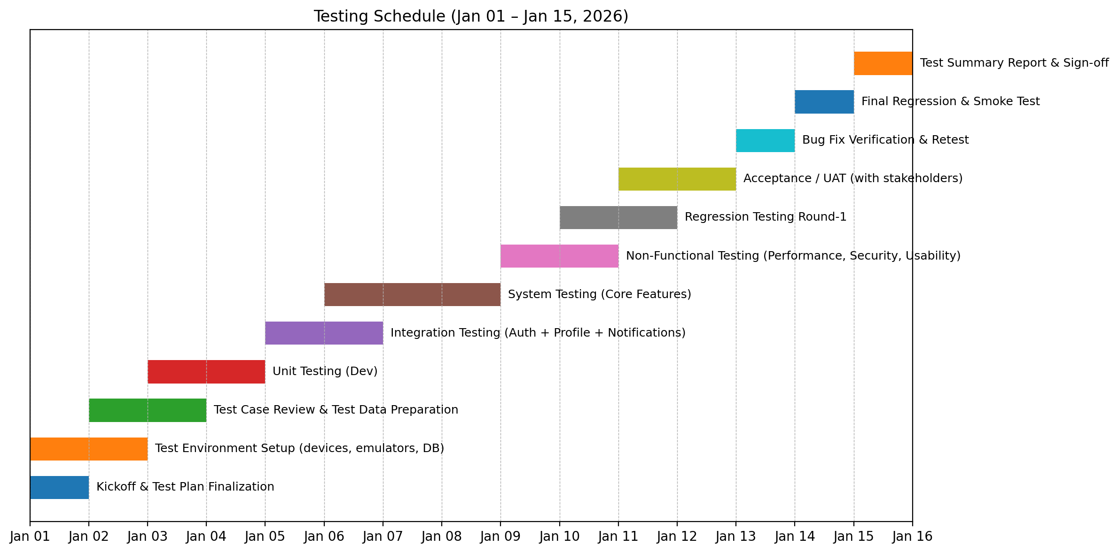
Figure 4: SHAAS Testing Schedule (Jan 01 – Jan 15, 2026)

PLANNING RISKS AND CONTINGENCIES
Key Risks:
• Device fragmentation: Multiple Android versions and screen sizes may introduce UI/permission issues.
• External API dependency: Weather/AQI/maps services can be slow, rate‑limited, or temporarily unavailable.
• Security/privacy risks: Incorrect permission handling or insecure storage could expose sensitive user data.
• Compressed timeline: The Jan 01–Jan 15 window may limit full device coverage.
• Stakeholder availability: Delays in UAT feedback can affect final approval.
Contingencies/Mitigation:
• Prioritize testing for critical workflows first (auth, profile, reminders, appointment, helpline).
• Use fallback responses, caching, and mocked test endpoints when external providers fail.
• Apply a strict defect triage policy and daily reporting to keep focus on high impact issues.
• Allocate buffer time for retest/regression (Jan 13–Jan 14).
• Maintain a sign‑off checklist so approvals are based on measurable criteria.

APROVALS

The undersigned acknowledge that they have reviewed this Test Plan and approve it for use in the SHAAS project.
Name | Role | Signature | Date
Zobayer Islam Jony | Prepared By (Team) |  | 15/01/2026
Shemanto | Prepared By (Team) |  | 15/01/2026
Afia Sultana | Prepared By (Team) |  | 15/01/2026
Course Instructor | Reviewed/Approved By

